**PIZZA SALES SQL QUERIES**

**A. KPI’s**

**1. Ingresos totales:**

SELECT SUM(total_price) AS Ingresos_totales FROM pizza_sales;



**2. Valor promedio de pedido**

SELECT (SUM(total_price) / COUNT(DISTINCT order_id)) AS Valor_promedio_de_pedido FROM pizza_sales;

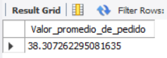

**3. Total de pizzas vendidas**

SELECT SUM(quantity) AS Total_de_pizzas_vendidasFROM pizza_sales;

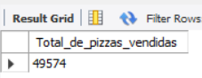

**4. Total de ordenes**

SELECT COUNT(DISTINCT order_id) AS Total_de_ordenesFROM pizza_sales;

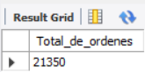

**5. Promedio de pizzas por orden**

SELECT CAST(CAST(SUM(quantity) AS DECIMAL(10,2)) /

CAST(COUNT(DISTINCT order_id) AS DECIMAL(10,2)) AS DECIMAL(10,2))

AS Promedio_pizzas_por_orden FROM pizza_sales;

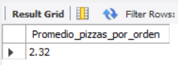

**B. Tendencia diaria de pedidos totales**

SELECT

DAYNAME(STR_TO_DATE(order_date, '%d-%m-%Y'))ASDia_de_la_semana,

COUNT**(**DISTINCTorder_id)ASCantidad_de_pedidos

FROMpizza_sales

GROUP BY Dia_de_la_semana;

***Output:***

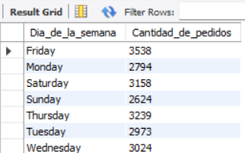

**C. Tendencia mensual de pedidos**

SELECT

MONTHNAME(STR_TO_DATE(order_date, '%d-%m-%Y')) AS Mes_del_año,

count(distinct order_id) AS Cantidad_de_pedidos

FROM pizza_sales

GROUP BY Mes_del_año

ORDER BY Cantidad_de_pedidos desc;

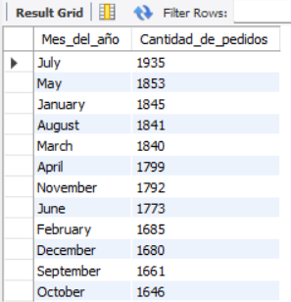

**D. Porcentaje de ventas por categoría**

SELECT

pizza_category,

ROUND(SUM(total_price),4) AS total_ventas,

ROUND(SUM(total_price) * 100 / (SELECT SUM(total_price) FROM pizza_sales),2) AS Porcentaje_del_total_de_ventas

FROM

pizza_sales

GROUP BY pizza_category;

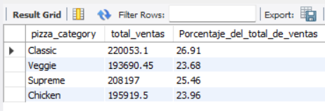

**E. Porcentaje de ventas por tamaño de pizza**

SELECT pizza_size,

ROUND(SUM(total_price),2) AS total_de_ventas,

ROUND(SUM(total_price) * 100 / (SELECT SUM(total_price) FROM pizza_sales),2) AS porcentaje_del_total_de_ventas

FROM pizza_sales

GROUP BY pizza_size

ORDER BY porcentaje_del_total_de_ventas DESC;

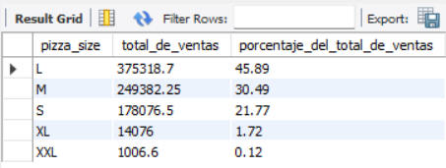

**F. Cantidad de pizzas vendidas por categoria**

SELECT pizza_category,

SUM(quantity) as cantidad_de_unidades_vendidas

FROM pizza_sales

GROUP BY pizza_category

ORDER BY cantidad_de_unidades_vendidas DESC;

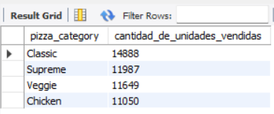

**G. Top 5 Pizzas que generan mas ingresos**

SELECT pizza_name,

SUM(total_price) AS ventas_totales

FROM pizza_sales

GROUP BY pizza_name

ORDER BY ventas_totales DESC

LIMIT 5;

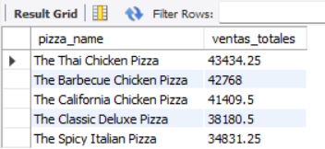

**H. Top 5 Pizzas que generan menos ingresos**

SELECT pizza_name,

ROUND(SUM(total_price),2) AS ventas_totales

FROM pizza_sales

GROUP BY pizza_name

ORDER BY ventas_totales ASC

LIMIT 5;

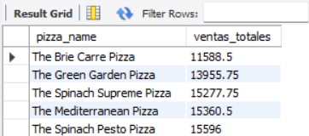

**I. Top 5 Pizzas mas vendidas**

SELECT pizza_name,

SUM(quantity) AS cantidad_vendida

FROM pizza_sales

GROUP BY pizza_name

ORDER BY cantidad_vendida DESC

LIMIT 5 ;

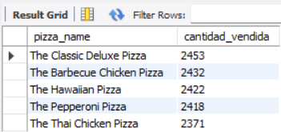

**J. Top 5 Pizzas menos vendidas**

SELECT pizza_name,

SUM(quantity) AS cantidad_vendida

FROM pizza_sales

GROUP BY pizza_name

ORDER BY cantidad_vendida ASC

LIMIT 5 ;

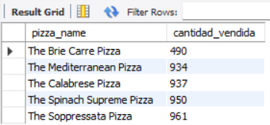

**K. Top 5 Pizzas por total de ordenes**

SELECT pizza_name,

COUNT(distinct order_id) AS cantidad_de_ordenes_vendidas

FROM pizza_sales

GROUP BY pizza_name

ORDER BY cantidad_de_ordenes_vendidas DESC

LIMIT 5;

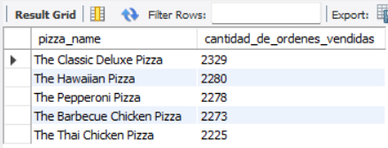

**L. Top 5 Pizzas menos vendidas por cantidad de ordenes**

SELECT pizza_name,

COUNT(distinct order_id) AS cantidad_de_ordenes_vendidas

FROM pizza_sales

GROUP BY pizza_name

ORDER BY cantidad_de_ordenes_vendidas ASC

LIMIT 5;

